- Title of the invention:

Venom classification using neural networks based on snake’s hissing sound.

- Field /Area of invention:

Venom Classification, Neurotoxic, Hemotoxic, Hissing Sound, Neural Network

- Prior Patents and Publications from literature (provide a table summarizing the prior art)

Patent / Publication | Description | Relevance to the invention
Oikarinen, T., et al. “Deep Convolutional Network for Animal Sound Classification.” Journal of Biological Systems, 2019, | Describes end-to-end CNN approaches for classifying animal calls from noisy recordings using spectrogram inputs, demonstrating robust performance across species. The study provides a clear methodology employing MFCC and spectrogram features as inputs to CNN models. | Establishes that CNNs combined with spectrogram-based features are effective for animal sound classification—directly applicable to developing neural models for snake hiss classification.
Chu, H.-C., et al. “A CNN Sound Classification Mechanism.” Sensors, vol. 23, no. 12, 2023. | Proposes a sound classification pipeline utilizing MFCC and spectrogram features, CNN architecture, and data augmentation techniques. The study also discusses approaches for managing noisy, real-world recordings. | Offers reusable methods for audio feature extraction, data augmentation, and CNN-based modeling—particularly suitable for hiss recordings collected in field or noisy environments.
Russell, A. P. “Vocalization by Extant Nonavian Reptiles: A Synthetic Overview.” Zoological Journal of the Linnean Society, 2021. | Provides a comprehensive review of reptile vocalizations, including snake hisses, covering production mechanisms, acoustic parameters (frequency bands, broadband frication), and interpretive challenges. | Explains the acoustic characteristics of snake hisses—broadband, fricative-like signals—essential for feature engineering and understanding discriminative sound properties.
de Solan, T., et al. “Looking for Mimicry in a Snake Assemblage / The Snake Hiss: Acoustic Mimicry.” bioRxiv, 2019–2020, | Studies acoustic variation in snake hiss calls and tests whether predators/discriminators can distinguish species or venomous status — explores concept of acoustic mimicry (harmless species imitating venomous hiss). | Important limitation / risk: shows hisses can be similar across species (acoustic mimicry) — this affects the discriminative power of hiss-only models and should be considered in your novelty / robustness analysis. (biorxiv.org)
Naresh, E., et al. “A Novel Framework for Detection of Harmful Snakes Using Machine Learning.” Lecture Notes in Networks and Systems, Springer, 2023. | Proposes ML pipeline to detect/differentiate harmful snakes using visual data (images) and ML; discusses data collection, model training and field deployment aspects. | Relevant system design lessons: although image-based, provides deployment considerations, dataset balancing, field-noise and false positive handling useful for an audio-based system. (SpringerLink)
Indian Patent Application. “A Portable Snake Detection and Warning Device.” Publication No. 201911028234, Indian Patent Office, 2019. | Describing a portable device that detects low-frequency signals and hissing sounds (10 Hz–1 kHz), extracts frequency and intensity parameters, compares them with a preloaded dataset, and issues alerts. | Utilizes hiss decoding and a preloaded classifier for snake detection; directly overlaps with audio-based detection claims. Review the claim scope carefully if proposing patents involving hiss-based detection.
Indian Patent (SRMIST). “Thermal Imaging for Snake Detection in Agricultural Fields.” Publication No. 202141061531, Indian Patent Office, 2021. | Indian published patent listing for thermal or infrared (IR)–based snake detection using machine vision and thermography, designed for agricultural applications. | Demonstrates that other universities and research centers are developing snake detection systems—useful for differentiating claims
Indian Design Entry. “Enhanced AI-Based Snake Detection and Control Device.” Design Registration, Indian Design Office, 2021. | Institutional record of Indian patent and design filings for AI-based snake detection and control, encompassing audio, AI, and thermal variants. | Indicates multiple recent Indian filings in AI-based snake detection; underscores the need to define novelty clearly—e.g., venom classification from hisses versus general snake detection.
World Intellectual Property Organization (WIPO). “One-Step Rapid Snake Envenomation Detection Kit.” WO2017109660A1, 2017. | Lateral-flow immunoassay kit designed to detect venom toxins in blood and distinguish neurotoxic from hemotoxic venoms within approximately one minute. | This patent addresses biochemical venom-type detection through blood assays. If your claims focus on noninvasive, audio-based venom classification, differentiation from biochemical assays is essential, as they address distinct technical problems.
United States Patent and Trademark Office (USPTO). “Compositions and Methods for Snake Venom–Related Detection and Treatment.” U.S. Patent No. 11,738,031 B2, 2024. | Recent U.S. patent family covering venom-derived compositions and biochemical methods, including therapeutic and compositional claims. | Not directly audio-based, but illustrates ongoing patent activity in biochemical and venom-related domains, highlighting a crowded IP landscape.
United States Patent and Trademark Office (USPTO). “Microfluidic Coagulation Assay Referencing Snake Venom.” U.S. Patent No. 9,910,053 B2, 2018. | Patent describing clotting/coagulation assay platforms which in background cite snake venom uses — shows lab assay IP for venom-related diagnostics. | Contrast with audio approach: again, different measurement modality; useful for prior-art mapping when you claim “venom classification” (i.e., establish non-obviousness over lab assays). (Google Patents)

- Summary and background of the invention (Address the gap / Novelty)

Existing snake detection systems mainly rely on visual, thermal or biochemical assays for the identification of species or venom type. There is limited prior research on acoustic based identification, and the available Indian patent filings focus only on detecting the presence of snakes using hiss patterns without classifying venom characteristics. Currently, no system uses neural network-based modelling of snake hissing audio signatures to differentiate venom category or venom potency class. The proposed invention addresses this critical gap by developing a deep learning-based venom classification model using snake hissing sound features, providing a non-invasive, field deployable and rapid classification approach for venom type prediction, especially in outdoor rural environments.

- Objective(s) of Invention

- To develop a neural network based audio feature extraction and classification model uniquely trained from snake hissing signals for venom type identification.

- To generate standardized hiss acoustic signature datasets from multiple venomous and non-venomous snake species enabling robust spectral fingerprint based venom classification.

- To implement a rapid, field-deployable, non-invasive venom classification solution operable in rural outdoor conditions eliminating dependence on laboratory biochemical diagnostic techniques

- Working principle of the invent (in brief)
The SnakeNET architecture is an AI based computational framework designed for automatic snake venom category classification using snake hissing sound signals. The complete workflow converts raw input audio into a refined deep learning representation, finally predicting whether the venom category is Neurotoxic or Haemotoxic. The entire pipeline consists of five major phases: Preprocessing, Data Augmentation, Mel Spectrogram Conversion, CNN based feature extraction, and Classification output.
The working principle starts with receiving an input snake hissing audio. These sounds can be collected in field using microphones, bioacoustics devices, or high resolution wildlife research audio loggers. Since field audio always contains multiple variations like surrounding noise, variations in mic distance, wind sound, insect background etc., the first block performs Preprocessing. It includes trimming the audio segment to isolate the valid snake hiss region and resampling the audio to a fixed sampling frequency. This standardization ensures uniform time domain representation for all snakes regardless of recording condition. The preprocessing steps ensure the raw waveform consistency so that downstream deep learning model receives same sampling dimension for training and inference.
After preprocessing, the model proceeds to Data Augmentation. Since biological datasets are always limited and it is extremely difficult to bring large numbers of venomous snakes into controlled labs, augmentation artificially increases dataset size. Pitch shift simulates audio tone variations representing different snake sizes and vocal tract changes. Time stretching modifies temporal speed without changing pitch representing natural movement rate variations. Volume scaling simulates recording strength differences. Together, these augmentation operations significantly improve generalization capability of the model and reduce overfitting.In the next stage, the signal transformed into Mel Spectrogram. The Mel scale represents human auditory perception mapping and is commonly used in speech recognition and bioacoustics signal classification. The Mel spectrogram converts audio waveform into 2D spectrum image containing both time frequency energy distribution. This image representation highlights spectral patterns unique to neurotoxic and haemotoxic species hiss signatures in frequency domain. HD audio wave conversion ensures minimal information loss, supporting deeper CNN feature extraction.
The converted 2D Mel spectrogram image is then passed into a Convolution Neural Network (CNN). CNN performs filtering to extract frequency dependent features, identifies snake specific signature peaks, spectral harmonics energy concentration regions, hiss turbulence patterns and spectral texture that differentiate venom physiology based on species family. Pooling operation reduces dimension and selects most important discriminative features automatically. Dense layer networks finally compress the learned feature vectors into final separable feature embeddings. Finally, the output layer performs classification into two classes: Neurotoxic venom category or Haemotoxic venom category. The decision helps field researchers, anti-venom research labs, forest departments, rural medical support teams and emergency poison care hospitals to identify venom category rapidly using only sound data. This significantly reduces time taken to identify species physically and enables fast anti-venom selection which is extremely crucial because time window to save snake bite victims is extremely short. The entire SnakeNET architecture therefore converts sound into intelligence using deep learning bioacoustics.

- . Description of the invention in detail (Include drawing and or photograph as needed)

This SnakeNET architecture in Figure 1 represents the complete deep learning pipeline for venom type classification using snake hissing audio signals. The input sound first undergoes preprocessing such as trimming and resampling to standardize all recordings. Then data augmentation techniques like pitch shift, time stretching and volume scaling expand dataset variability. The processed audio is converted into Mel spectrogram which transforms wave signals into 2D time-frequency representation. A Convolutional Neural Network extracts spectral features through filtering, pooling and dense layers. Finally, the system classifies the venom category as Neurotoxic or Haemotoxic. This architecture enables accurate bioacoustic venom prediction.

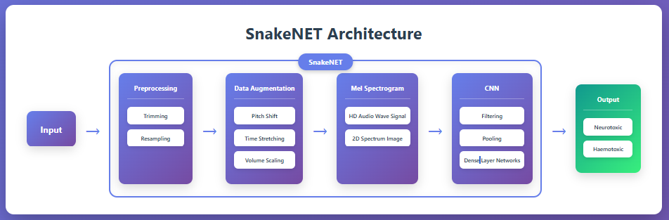
Fig. 1 Proposed Framework

- Experimental validation results:

Effective snakebite treatment relies on identifying the type of snake that bit the victim—neurotoxic or haemotoxic—and administering the appropriate antivenom. However, victims often struggle to distinguish between neurotoxic and haemotoxic snakes due to their similar structures.To address this challenge, we developed an AI-based Convolutional Neural Network model called SnakeNET. In general, a snake gives warning or threat sounds like hiss or rattling of its tail before biting a person. Thus, SnakeNET is trained on the warning sounds of neurotoxic snakes (Cobras, King Cobras) and haemotoxic snakes (Rattle Snakes and Vipers). It then classifies whether the snake is neurotoxic or haemotoxic with confidence.

The proof-of-concept for SnakeNET has been demonstrated based on the following process:

1. Raw Snake Sound Processing: The raw snake’s warning sound is processed to remove silence and noises.
2. Data Augmentation: Ambient noise, volume scaling, and pitch shifting are applied to the processed sound.
3. 1D Audio Wave Conversion: The processed 1D audio wave sound is converted to a 2D spectrogram image for input into the Convolutional Neural Network model.
4. Model Training: The model is trained on these spectrograms, enabling it to classify the output as neurotoxic or haemotoxic snakes with accuracy.

This SnakeNET model has given the accuracy of 98.71 % with our sample dataset – approximately 500 records of even distribution of neurotoxic and haemotoxic snakes’ warning sounds. The results are given below:

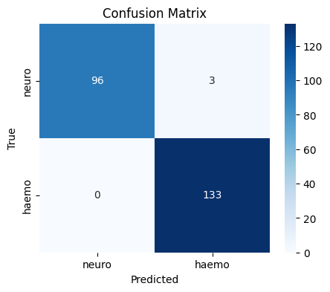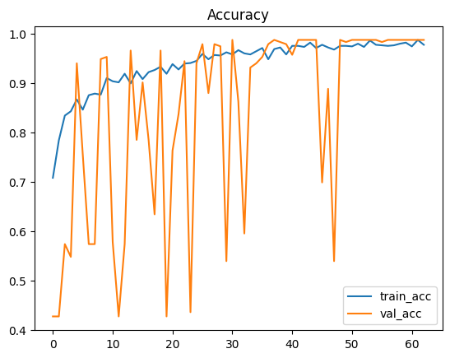

Fig.1: Confusion Matrix Fig. 2 : Accuracy_curve

- What aspect(s) of the invention need(s) protection?

- What is Technology readiness level of your invention? (Tick the appropriate TRL)

Research |  |  | Development |  |  | Deployment
TRL 1 | TRL 2 | TRL 3 | TRL 4 | TRL 5 | TRL 6 | TRL 7 | TRL 8 | TRL 9
Basic | Technology | Experimental | Technology | Technology | Technology | System | System | Actual system
Principles | concept | proof of | validated in | validated in a | demonstrated | prototype | complete | proven in an
observed | formulated | concept | a lab | relevant | in a relevant | demonstration | and | operational
 |  |  |  | environment | environment | in an | qualified | environment
 |  |  |  | (industrially | (industrially | operational |  | (competitive
 |  |  |  | relevant in | relevant in | environment |  | manufacturing
 |  |  |  | case of key | case of key |  |  | in case of key
 |  |  |  | enabling | enabling |  |  | enabling
 |  |  |  | technologies) | technologies) |  |  | technologies,
 |  |  |  |  |  |  |  | or in space )

----------------------END OF THE DOCUMENT-----------------------------

